

Connor Dillon

Connect Enterprise

25/03/2015

System Upgrade

**Table of Contents**

**1.0 Glossary of Terms Page 3**

**2.0 Analysis of Brief Page 4**

**2.1 Problem Analysis Page 5**

**2.2 Aims of the Project Page 6**

**2.3 Requirements Page 7**

**2.4 Key Factors Page 8**

**2.5 Resources and Materials Page 9**

**2.6 Hardware & Software Information Sources Page 10**

**2.7 Risk Assessment Page 11**

**2.8 Analysis Page 12/13**

**2.9 Project Planning Page 14**

**3.0 Development Page 15**

**3.1 Implementing the Planned Solution Page 15**

**3.1.1 Software Recommendations Page 15**

**3.1.2 Software Access Page 16**

**3.1.3 Installation and configuration of operating system and applications software Page 16**

**3.2 Hardware Recommendations Page 17**

**3.2.1 Installation and configuration of network nodes Page 18**

**3.3 Installing and configuring shared printers Page 19**

**3.3.1 Printing Permissions Page 19**

**3.4 Implementation of users, groups and security User and Group Structure Page 19**

**3.5 Folder/File Structure Page 20**

**3.6 Web Presence Page 20**

**3.6.1 Email System Page 21**

**3.7 Security Recommendations Page 21**

**3.8 Backup Recommendations Page 21**

**3.9 Remote Access Recommendations Page 21/22**

**3.10 Group Policy’s Page 22**

**3.11 .MSI Deployment Page 22**

**3.12 Testing the Implemented Solution Page 23/24**

**3.13 Managing the Project Page 24/25**

**3.14 Document any changes from project plan Page 25**

**4.0 Evaluation Page 26**

**4.1 Outline the Assignment Page 26**

**4.2 Strength and Weaknesses Page 27**

**4.3 Recommendations Page 27**

**4.4 Modifications Page 27**

**4.5 Knowledge and skills Page 27**

**5.0 Appendix A Page 28/42**

**6.0 Appendix B Page 43**

**1.0 Glossary of Terms**

**Term Definition**

|  |  |
| --- | --- |
| Ad hoc | Is a local area network (LAN) that is built spontaneously as devices connect.(WhatIs, 2015) |
| VPN – (Virtual Private Network) | Data sent over internet, encrypted when sending and decrypted at receiving end. |
| Mbps – (Megabits per second) | A measurement of data transfer speed. |
| ISP – (internet service Provider) | A company that provides internet services. |
| WAN (Wide area network) | A network that covers a large area. |
| VLAN’s (Virtual Local Area Network) | Same properties of a LAN (local area network); configured through software rather than hardware. |
| IPS (Intrusion Prevention system) | Identify, classify and stop malicious attacks on the network. |
| RAID | Storage that uses multiple disks to provide fault tolerance. |
| Class C | Network addressing architecture. |
| Static | A constant IP address. |
| NTFS | Proprietary file system. |
| Brute force | Program that will guess passwords until correct. |
| Black-hole VLAN | VLAN configured for unused ports; security practice. |
| Bottleneck | Hardware unable to provide speed the network is supporting. |

**2.0 Analysis of Brief**

TransMem, a small company based in Central Scotland consisting of ten personnel located in Glasgow with the exception of one employee being located in Edinburgh. TransMem who supply flash drives and memory cards for phones and cameras to local companies and clients further afield have employed Connect Enterprise to design, implement and document the creation of the business’s new network infrastructure. Connect Enterprise has been assigned this task as the ad hoc network TransMem currently use has become slow and unreliable due to a design that does not support their expanding network. Another core factor causing the current system to remain outdated is that the software packages the company is using have not been upgraded to the latest version. Connect Enterprises final product should provide TransMem with a new system that is stable, fast and is legally compliant, to ensure that both companies are not susceptible to any lawsuits.

**2.1 Problem Analysis**

After assessing the project brief Connect Enterprise have concluded that the following basic requirements are predominant in the new system. Any following modified and suggested requirements have been fully accepted by TransMem.

|  |  |  |  |  |
| --- | --- | --- | --- | --- |
| **Basic Requirement** | **Full Requirement** | **Agreed (Fully/Modified)** | **Details of Modification if applicable** | **Accepted by Client** |
| Applications all staff | ✔ |  |  |  |
| Applications Sales staff | ✔ |  |  |  |
| Applications Purchasing staff | ✔ |  |  |  |
| Applications Accounting staff | ✔ |  |  |  |
| Web Development tools Sales Manager | ✔ |  |  |  |
| Networked PCs | ✔ |  |  |  |
| Server Infrastructure |  | ✔ | Failover server incorporated |  |
| Network Infrastructure |  | ✔ |  |  |
| Printing | ✔ |  |  |  |
| User Structure | ✔ |  |  |  |
| File Storage all staff | ✔ |  |  |  |
| File Storage Managers |  |  |  |  |
| File Storage Managing Director | ✔ |  |  |  |
| Web Access | ✔ |  |  |  |
| Email Access | ✔ |  |  |  |
| Security |  | ✔ | Antivirus software, IPS logging & login hours |  |
| Backup |  | ✔ | Every night : 10pm-6am |  |
| Remote Access |  | ✔ | Provided via VPN |  |
| UPS |  |  |  | ✔ |
| Wireless Access |  |  |  | ✔ |

**2.2 Aims of the Project**

After reviewing the project brief Connect Enterprise has concluded that the network must meet all the stated requirements, to produce a network that will be adequate for TransMem’s business within the allocated time. The final solution should demonstrate a fast and reliable network. This network should have minimal threat from internal and external attacks, to provide a secure and legally compliant business network which will be implemented through the use of firewalls and antivirus software set to regularly perform security scans. Also the implementation of restrictions will also be exhibited in the finalized network, to decrease distractions by only allowing employees access to needed applications/software and will also reduce security risks. The network must have ten networked PC’s and five networked printers that can be accessed by the corresponding employees. They will also be provided with an allocated amount of private file storage space. Certain titles within the network specified in the project brief, must have access to employees private files belonging to staff within their department. This will let the company run scheduled file audits, again helping improve the networks security internally. Another aim of this assignment is to create a web presence for TransMem. The current network is unreliable and TransMem have requested that their new network must implement regularly occurring backups to remove the potential disaster of data loss. Also the Edinburgh user must have a way to access the company’s internal network. In this case Connect Enterprise will be implementing this, via a secure and fast VPN that will restrict the user to certain applications/protocols through the use of the VPN policies and group policies, giving the user the correct amount of access to the network.

To provide a network that is fast and reliable, Connect Enterprise will have to purchase new hardware and software to ensure speed and stability. The selection of hardware and software will be a primary task for Connect Enterprise as, without reliable and fast software and hardware, TransMem would not be satisfied with the final product that would be produced. To ensure that the hardware and software is to a high standard it will be purchased from respected and recognized vendors/retailers.

The appropriate user structure will also have to be identified and designed. This will be designed in a hierarchical layout to clearly identify what users are assigned to each department and what users have a more privileged level of title within the company. This information will be extracted from the project brief. This will help Connect Enterprise visualize and implement a system, in which the users will have the appropriate assignment to departments and correct access/authorization to folders and applications.

In summary, Connect Enterprise must meet the requests made by TransMem in this network; it has to be secure, fast, and robust and restrict specific users to a certain level of access and allow files to be totally overseen by certain titles within the company. These aims must be met within the allocated time, to provide a finalized network that will be satisfactory for TransMem’s business and to ensure that the network will be ready when required. Once the network is finalized and implemented, Connect Enterprise will also have to provide a documented and tested report to prove that the network meets all aspects of TransMem’s project brief.

**2.3 Requirements**

The project brief establishes what requirements the network must meet to function the way TransMem expect. Requirements TransMem have requested that the network must support are located in the criterion section of the project brief. These requirements can be categorized under the titles functional requirements and non-functional requirements. Constraints that will affect the project from the outset and throughout are time, cost and regulatory requirements.

|  |  |  |
| --- | --- | --- |
| **Requirement** | **Functional** | **Non-Functional** |
| 10 Networked PC’s. | ✓ |  |
| All staff access to a generic office suite. | ✓ |  |
| Sales Staff access to a sales ledger and specialized contact management and sales tracking package. | ✓ |  |
| Private file storage for all staff. | ✓ |  |
| Managers access to all files including private files of staff within their department. | ✓ |  |
| Managing Director access to all files inducing entire company’s private storage. | ✓ |  |
| Web presence to sell directly online. | ✓ |  |
| Sales Manager can oversee web presence. | ✓ |  |
| Purchasing staff require access to purchase ledger software. | ✓ |  |
| A named member of the accounting staff requires access to a standard accounting package. | ✓ |  |
| A named member of the accounting staff requires access to a payroll package. | ✓ |  |
| Full internet access for: Managing Director and all purchasing staff. | ✓ |  |
| All other staff should be restricted to email. | ✓ |  |
| Each department should have its own printer, with access restricted to members of that department. | ✓ |  |
| The Managing Director requires a printer which is restricted to his own personal use. | ✓ |  |
| An additional backup printer requires to be made available to all staff. | ✓ |  |
| The network requires to be secured against relevant threats. |  | ✓ |
| All data requires to be backed up regularly. |  | ✓ |
| All staffs with the exception of management are restricted to local access from 8.00 am to 6.00 pm. |  | ✓ |
| Network is scalable and reliable. |  | ✓ |
| PC’s can boot within one and a half minute. |  | ✓ |
| System should provide ease of access. | ✓ |  |
| Failover server startup time should be less than 35 seconds. |  | ✓ |
| Passwords must meet a complexity level. |  | ✓ |

**2.4 Key Factors**

Throughout the project there are key factors that must be acknowledged as they influence the whole project from beginning to end. Time will be a key factor influencing the whole project; Connect Enterprise will have to keep to strict deadlines, produced by TransMem if the network is to be completed in time for its intended use. The Project Manager has created a project plan (Appendix A 5.1) in which Connect Enterprise’s staff will be expected to complete certain tasks to meet deadlines, inversely meeting TransMem’s deadlines. If the network is not designed, implemented and tested in time TransMem could potentially be left with no network and be out of business until the network is completed which is likely to result in loss of revenue. Monitoring employee’s progress in accomplishing tasks for these deadlines will help ensure that the work produced by Connect Enterprise is meeting expectations and maintaining the highest quality standard possible.

Secondly, a key factor that must be acknowledged throughout the project is that the network must be fast and reliable. Even from the design stage these factors must be recognized and the design of the network should support and provide speed and reliability. For the network to run reliably the hardware and software that the network is using should be sta

ble and supplied by a respected vendor/retailer. For the network to provide the speed required the hardware must also, again be supplied by a recognized vendor and be suitable for the tasks TransMem require to do. As well as having a network that can function fast internally, TransMem will want to have a connection that lets them access the WAN (wide area network) with decent speeds; this will help provide the Edinburgh user with a decent connection for accessing the remote network. The fast connection to the WAN will also help the appropriate users quickly update their web server to provide a quality experience to all the customers/users accessing it. If the network fails the speed and stability testing the whole project will have to be revised and amended to provide TransMem with the network that they have requested.

Thirdly, a key factor that must be produced to the best of Connect Enterprises standard is the network. If the company is to be supplied with a fully functioning ‘new system’ the network will have to provide a fully connected, stable and fast network. Without a fully functioning network a new business system will be impossible to provide to the standards that TransMem expect.

Another key factor affecting the entire project is the selection of hardware; hardware is a key component in any successfully functioning network. Having implemented powerful and reliable hardware will help prevent any bottlenecks due to slow hardware, thus making sure the network is functioning at the highest possible stable standard. Reliable hardware will be purchased from recognized and respect retailers and this will help ensure that the hardware is of a high standard and that if needed that customer care is available to the company.

Also, a user and group structure will have to be developed to ensure that employees are in correlation with the correct: job role, level of status, protocols access and application access. Without a user group structure the assignment of restrictions and access would prove extremely difficult to manage. A hierarchical design would be the most efficient way to demonstrate a user and group structure. This will be adequate way to establish user and group policy’s accordingly.

Finally, whilst the selection of hardware is a key component of any functioning network, the selection of software is arguably, just as important. The operating systems that the networked devices are running on will help ensure that all devices on the network are stable and able to successfully communicate with each other. On hardware such as switches and routers software is an important factor to establish that the devices are providing the best possible speed and user interface. Again purchasing from a recognized and respected retailer will mostly ensure that the software on the devices is function at an optimal level. These key factors will have to be focused on throughout the project plan if the network developed is to be to the highest possible standard for TransMem.

**2.5 Resources and Materials**

During the development of the company’s new system there will be resources that are vital to the project. Throughout the project Connect Enterprise will be cross examining customer feedback on distributer’s websites to ensure that when purchasing from retailers that the purchased goods do not have any common defects. There are many potential resources that will be accessed throughout the project; uk.pcmag’s website could be possible resources to ensure that the hardware being purchased has the correct specification and high standard needed for the network, with an overall analysis of the product produced by a respected author. PCpro’s website may also be used to ensure that the Operating systems the server and clients machines are running on is recommended and stable which can be seen easily by through the use of their rating system. Distributer websites such as [www.cisco.com](http://www.cisco.com) will be a key resource as some of their hardware may be used in the finalized system; Cisco’s data sheets will be examined in relation to potential hardware for the network. The project brief issued by TransMem was be an invaluable resource through the entire project. A final resource that will prove a huge asset for Connect Enterprise is TransMem/the client any clarification can be easily requested.

When purchasing the appropriate hardware and software Connect Enterprise will follow a seven step procedure to ensure that the best and most appropriate product is selected. Step one will be to identify the need of the product; this is where a product will be purchased due to it being key in the solution. Step two will be to select a product specifically; the product will after being identified have to be purchase due to its specifics such as what version or model. Step three will be to designate Connect Enterprises purchase team, who will deal with purchasing the products. Step four will be to create a list of technical specification that the finalized solution will need to ensure it meets TransMem’s requirements. Step five would typically be to establish a budget for the purchase team, in this case TransMem have not specified a budget. Step six to compile and research possible suppliers, identifying the most viable model and conducting if vendor’s are recommended and recognized for their products quality. Finally, the last step in purchasing procedure will be to select one of the researched suppliers. After comprehensive research and close collaboration with TransMem, Connect Enterprise has selected the materials needed to produce TransMem’s.

Typically Connect Enterprises Company would use all resources possible in order to complete this system in the specified time. Connect Enterprise has many departments within their company such as Network Engineering department, network technician department, testing team and quality control. Each department would be assigned to tasks correlating to their departments expertise, this would be beneficial as each stage would be carried out by employees experienced in that area; dedicating departments to certain stages of the project which would be displayed in the project plan, would also lead to the completion of the project in a reduced amount of time. In this case TransMem have requested that one employee carries out the creation of their new system.

There are resources that are definitely essential in order to complete the project. Connect Enterprises employees are paramount in order for any progress to be made on the creation of this project. Another vital resource is accommodation after the completion of the planning stage Connect Enterprise will need a site where they can begin to setup the requested new system. A final essential resource of the new system is the hardware and software without these main resources, the requested system would be impossible to devise.

**2.6 Hardware & Software Information Sources**

Information is crucial during the selection process; software and hardware will be used alongside each other to provide the fast stable user experience. Hardware manufacturer’s websites will be essential in identifying all aspects of the hardware and software specifications which will be present in the final product. In relation to the already selected hardware and software there were many essential sources of information; such as hardware manufacturer’s websites, software vendors websites, online retailers, technical support websites and customer reviews. Technical support is an important factor when purchasing any type of hardware and software.

|  |  |  |  |  |
| --- | --- | --- | --- | --- |
| Hardware | Manufacturer | Retailer | Tech Support/warranty | Main Specifications |
| Dell Optiplex 9010 AIO | Dell.co.uk | Amazon.co.uk | * 3-year Dell ProSupport | * Intel® Core™ i3 * Windows 7 Professional |
| HP LaserJet Pro 200 M251n | Hp.com | Store.hp.com | * 1-year warranty | * Print only * USB & Ethernet connectivity * Up to 30,000 prints per month * Up to 14 ppm |
| Cisco RV215W Wireless-N VPN Router | Cisco.com | Amazon.co.uk | * Support Fee * Cisco will only try to support if Point of Sale (Partner) is no longer in business | * A high-speed, 802.11n wireless access point * A 4-port 10/100 Mbps Fast Ethernet switch |
| Cisco Small Business SF300-24 - switch - 24 ports | Cisco.com | Amazon.co.uk | * Support Fee * Cisco will only try to support if Point of Sale (Partner) is no longer in business | * Primary Ports -24 x RJ45 * Primary Port Speed -10/100Mbps |
| Dell PowerEdge R420 | Dell.co.uk | Amazon.co.uk | * Dell ProSupport Plus – subscription fee | * Processors - Intel® Xeon® processor E5-2400 and E5-2400 v2 product families * OS-Microsoft® Windows Server® 2012 * Cache - 2.5MB per core; core options: 4, 6, 8, 10 |
| Dell PowerVault NX400 | Dell.co.uk | Amazon.co.uk | * Dell ProSupport Plus – subscription fee | * Max Internal Capacity - 16TB raw capacity (with 4TB NL-SAS) * RAID 5 * OS-Windows® Storage Server 2012 R2 |
| Broadberry -CyberStore P10 DSS iSCSI SAN / NAS Configure | Broadberry. com | Amazon.co.uk | * 3-year warranty as standard. | |  |  | | --- | --- | | * Intel Xeon (Quad Core) E3( 1220 v3 ) 3.1GHz 8MB * Chassis Broadberry CyberStore XE3-P1 -Broadberry CyberStore XE3-P1 |  | |
| APC BE700G-UK 405 Watts /700 VA, Input 230V /Output 230V, Interface Port USB Power-Saving Back-UPS | Apc.com | Amazon.co.uk | * Chat with Tech support Agent * Warranty | * Output Power Capacity 405 Watts / 700 VA * Topology Standby * Typical recharge time 16 hour(s) |

Software will also need to go through Connect Enterprises six step methodology when purchasing the appropriate software. Information is equally as crucial in the software selection as it is in the hardware selection. After following the six step selection process these results were produced.

|  |  |  |  |  |
| --- | --- | --- | --- | --- |
| Software | Vendor | Retailer | Tech Support | Key Features |
| Windows 7 Professional | Microsoft.com | * (provided with hardware) | * Phone, email or chat support. | * Full 64-bit support * Ease of Access Centre * Performance improvements |
| Windows Server 2012 | Microsoft.com | * (provided with hardware) | * Phone, email or chat support. | * Active Directory Certificate Services Overview * Active Directory Domain Services Overview * [Active Directory Rights Management Services Overview](https://technet.microsoft.com/en-gb/library/hh831364.aspx) * [Group Policy Overview](https://technet.microsoft.com/en-gb/library/hh831791.aspx) * File and Storage Services Overview |
| Sage Instant Accounts 2015 (standard) | Sage.co.uk | Amazon.co.uk | * SageCover Membership subscription | * Get up and running in a few simple steps * [Anytime, anywhere access](https://www.sage.co.uk/sage-instant-accounts/key-features#H2) * [Understand your business performance](https://www.sage.co.uk/sage-instant-accounts/key-features#H3) * [Manage your cash flow](https://www.sage.co.uk/sage-instant-accounts/key-features#H5) |
| Sage Instant Accounts 2015 (financial Package) | Sage.co.uk | Amazon.co.uk | * SageCover Membership subscription | * Manage Customers and Suppliers * Automate your processes * Manage your Finances |
| Office 365 Business | Microsoft.com | Products.office.com | * Online help * Community forums * Call support | * Always have access to up to date software * Accessible on multiple devices |
| Small locally installed CRM (customer relations management) package for Sales and Marketing (SuperOffice) | Superoffice.co.uk | Superoffice.co.uk | * Book meeting to talk about CRM needs. * Call support | * Ticket/Request Management * Multi-Channel Communication * Complete 360° View of Customer Information in One Place * Escalation & Alerts » |
| The Sage 200 Sales and Purchase Ledgers ( for purchase ledger) | Sage.co.uk | Sage.co.uk | * Email support * Call support | [Customisable business-wide software](https://www.sage.co.uk/sage-200/key-features#H1)  * [One view of your customers](https://www.sage.co.uk/sage-200/key-features#H2) |
| BitDefender Small Security Office (yearly) | Bitdefender.com | Bitdefender.com | * Email, Chat, Forum and phone support. | * Protects: PC, Mac, File Servers. * Support 24/7 * Central Management * Maximum seats 250 |

**2.7 Risk Assessment**

The following risks have been established as possible factors that could prevent or delay the completion of the new development.

|  |  |  |  |
| --- | --- | --- | --- |
| **Risk** **Description** **Rating** **Precautions** | | | |
| 1. New system not providing all requirements specified. | Requirements are not understood and they are not fully incorporated in the final produce. | **High** | * Hold regular meeting with the company to ensure complete understanding. |
| 1. Final produce is not to a high standard. | Quality has not been focused on throughout the project. Resulting in an unstable and poorly documented system. | **High** | * At the end of every stage assign quality control to ensure the produce is to a high standard. |
| 1. Client becomes uninterested. | Client has become uninterested with the new system. | **High** | * Engage with the client. * Update the client with the systems progress. |
| 1. Incompetent development team. | Development team do not have the appropriate skills to carry out the development. | Medium | * Ensure that the individuals with the correct skillset are assigned to the task. |
| 1. Unable to meet deadlines. | Due to unforeseeable workloads and unrealistic deadlines the system is not completed in the agreed timescale. | Medium | * Examine each step needed and realistically assign an allocated amount of time. |
| 1. Disgruntled employees. | Employees are unhappy with their current role in the workplace, which could result in low quality of work and slow progression. | Low | * Hold regular internal meetings. * Ensure that employees feel as though their skills are being applied to the best suited tasks. |
| 1. Price fluctuation. | Prices may rise and fall due to high demand, resulting in a change in final approximated cost. | Low | * Purchase all products at the same time, leaving little time for price fluctuation. * Re-source the product for the originally intended cost. |
| 1. Supplier declares themselves as bankrupted. | An unanticipated cost or a constant loss in revenue resulting in bankruptcy. | Low | * Re-source the product as quickly as possible to reduce ramifications. |

**2.8 Analysis**

Research was carried out using the following resources and techniques: online sources, offline sources, review of existing documentation and interviews with staff involved. Online sources were used to ensure that Connect Enterprise were selecting from a wide range of possibilities and to ensure the products specifications met the needs of TransMem’s system; overall increasing the standard of products selected. Offline resources were accessed in order to ensure that the information from the online resources were factual. Connect Enterprise considered TransMem’s project brief for a considerable amount of time to ensure that the new system was clear in the aspect of what it must provide. Throughout the planning stage of this project, TransMem have been contacted to verify any new additions to the network plan and ensure that the Connect Enterprise have an extensive understanding of how their current system operates and how the new system should operate. As well as contacting TransMem’s staff, Connect Enterprise have monitored and interviewed their own staff that have been assigned to the project to ensure that they are meeting deadlines and producing a high quality of work.

A network topology has been designed and created in accordance to all requirements and specifications TransMem have requested. The topology will assist Connect Enterprise during the development stage and will be presented to TransMem to ensure that the new system is what is required and expected (Appendix A 5.3). This network topology was designed as a centralized topology; the downside of this design is that if the switch fails all users will lose complete access excluding any users connected to the wireless connection.

Information extracted from the project brief stating; each member of the company and what department they are assigned to this will be key in understanding the current systems user structure and developing a strategy to design and implemented a user structure in the new system. After the information was analyzed Connect Enterprise concluded that it would be most suitable to implement and design the new user in a hierarchical layout which can be displayed in appendix A 5.3. Each department and users will be organized into organizational units and assigned the correct group policies to restrict certain department’s access.

VLAN’s are also going to be implemented in the new system to add a layer of security to the network. A static IP addressing scheme will also be implemented in the new system due to the use of VLAN’s being used as it is more suited to assigning users and departments to specific VLAN’s.

Connect Enterprise have established that security must be to a high standard within the new system, as well as protecting the company from external threats each user account must be protected for malicious software and unauthorized access. Username and passwords will be implemented to prevent access from unauthorized personnel; these passwords will have to meet certain criteria in order for the password to be viable; this will be done through password policies. Security is an immense factor and will be explored extensively. Failure to implement solid security and provide secure private storage could lead to TransMem open to legal action and facing legal prosecution for breaching laws such as the the Data Protection Act 1987 .

During and after the development stage the new system will be tested methodically to ensure that all components in the new system are functioning correctly. After setting up the individual ten PC’s each PC will individually tested to ensure that it is operating correctly and the peripherals are functioning correctly; if any issues are discovered the device will be returned to the original equipment manufacturer.

Secondly once any issues have been resolved the two servers will be booted and inspected to ensure that they are operating at a stable level. Once all PC’s and servers on the network are setup and Connect Enterprise has established that all devices currently are operating correctly and stably.

The next stage where testing will be required is ensuring that all printers are running correctly and this will be performed by printing a test page. The next step in the development stage that will need tested is when all components of the internal network are connected via Ethernet and issued an IP address that they are able to communicate and establish a stable connection between each device.

The next stage that will need to be tested is when the NAS (network attached storage) is installed on the internal network; it will be tested to ensure that every device in the network is able to view the network storage system. All users will be added to the domain and will be tested to ensure that after login they are prompted to ensure that their password meets the complexity requirements.

Once each and individual server role has been installed and tested. Then the router and switch will be incorporated into the network design and tested to ensure that they are function as expected. Connect Enterprise have also decided to test four specific deliverables at the end of the project to ensure full functionality and thorough testing:

* The Network
* User, Group and File Permissions
* Backup and Restore
* Network Access Permissions

VlAN’s, group policies and organizational units will be implemented and tested to restrict specific user’s access and department’s access to certain applications and protocols. Restrictions will also be contributing to reducing the risk of employees being prosecuted under the computer misuse act.

The new systems failover system will also have to have to be tested to ensure that if in any event where the main server fails that the failover server is able to act as the primary server and provide the same services and there is the lowest possible downtime during the failover server assuming the primary server role. Also the backup device will also have to be tested by insuring that all files on the network are being backed up regularly.

The final phase in the testing stage will be to login as the appropriate users and ensure that they are able to oversee all appropriate employees files. All other users will be logged in and tested to ensure they can access their shared file space and private file space. After ensuring all file space is operating correctly all user accounts will be tested to ensure they have restricted access to the correct protocols and applications.

Many deliverables must be produced in the end product and have been reviewed and stated in the project planning stage. Key deliverables are meeting all the company’s requirements stated in the project brief. These deliverables will be produced to the highest quality and standard possible. Connect Enterprise must produce these deliverables in a realistic and agreed timescale.

**2.9 Project Planning**

Connect Enterprise set high standards amongst their staff to produce the highest possible quality of work.TransMem have also set specific deadlines that have been agreed and must be met to ensure Connect Enterprise is providing TransMem with the highest quality of service in the allocated time. Connect Enterprise pride themselves in upholding these qualities and is key to their current success. To ensure that these points are met Connect Enterprise has created a project plan allocating certain tasks to specific dates to ensure that the project is completed in time and to a high standard; the project plan can be viewed in appendix A 5.1 or attachment “Project plan.mpp”.

**3.0 Development stage**

After intensive and attentive planning Connect Enterprise have established a project plan that is thorough and accurate. Connect Enterprise have assigned their quality control team to inspect and improve the planning documentation to ensure that documentation is provided to the highest possible standard. Once quality control had completed reviewing the project plan, Connect Enterprise proceeded to implement the planned solution.

**3.1.1 Software Recommendations**

Software is a core component of any reliably functioning network. Stability will be key in the production of this new system: Connect Enterprise will ensure this by purchasing from recognized vendors and being subject to their seven step purchasing procedure.

|  |  |  |
| --- | --- | --- |
| **Function** | **Selection** | **Comments** |
| Server OS | Windows® Server 2012 | * Pre-installed upon arrival * Still receiving Microsoft support |
| Client OS | Windows® 7 Professional | * Pre-installed upon arrival * Still receiving Microsoft support |
| Mail Service (external) | Rackspace Email | * Spam protection * 100% guaranteed uptime * Support available 24x7x365 |
| Security Suite | Bit Defender Small Security Office | * Support for up to 250 employees * Simplistic to manage |
| Web Server (external) | Web Hosting + Ecommerce + Managed Operations(Rackspace) | * Scales to your needs * Average uptime 99.9% |
| Web Development Tool(s) | NVU | * Easy to use * Free * Open source solution |
| Office Suite | Office 365 Business | * Supports PC, Mac and apps for tablets and phones * 1TB of online storage |
| Accounting | Sage Instant Accounts 2015 (standard) | * Easy to set up and use * makes managing your customers and suppliers easy * makes managing your business easy |
| Payroll | Sage Instant Accounts 2015 (financial Package) | * Market leading accounts software |
| Contact Management | Small locally installed CRM package for Sales and Marketing (SuperOffice) | * Simple and user-friendly * Supports all leading technology platforms |
| Sales Tracking | The Sage 200 Sales and Purchase Ledgers ( for purchase ledger) | * Tools to manage debtors and allow effective credit control. * Design supports fast data entry |

**3.1.2 Software Access**

Connect Enterprise have extracted what software employees must be able to access specified by TransMem in the project brief. The overall approximated cost of the software needed for the new system is £2798.40. Please refer to appendix A 5.4 for detailed pricing.

|  |  |  |  |  |  |  |  |  |
| --- | --- | --- | --- | --- | --- | --- | --- | --- |
| **User or Group Software** | **R Williamson** | **M Heron** | **Sales**  **Staff** | **C Palmer** | **Purchasing Staff** | **J Ingram** | **G Forbes** | **J Gilston** |
| Generic office suite | ✓ | ✓ | ✓ | ✓ | ✓ | ✓ | ✓ | ✓ |
| Sales ledger |  |  | ✓ |  |  |  |  |  |
| Purchase ledger |  |  |  |  | ✓ |  |  |  |
| Standard accounting package |  |  |  |  |  |  | ✓ |  |
| Payroll package |  |  |  |  |  |  |  | ✓ |
| Contact Management and sales tracking package |  |  | ✓ |  |  |  |  |  |

**3.1.3 Installation and configuration of operating system and applications software**

Connect Enterprise have established that client machines will come preinstalled with Windows 7 and servers will come preinstalled with Windows server 2012. As setting-up the operating systems manually on all machines would be time consuming, Connect Enterprise have decided to create an answer file to setup the server and create an answer file that will setup the Windows 7 PC’s and automatically join the TM.com domain. After install has completed all Windows 7 machines will be configured to a static IP address. Applications needed by TransMem’s corresponding departments will be deployed via group policies to ensure that the specified employees have access to the correct software packages.

**3.2 Hardware Recommendations**

Hardware is equally as important as software in order to provide a stable system. All hardware detailed below has been recommended after being subject to Connect Enterprises seven step purchasing procedure. Connect Enterprise have generated an invoice based on the costs of all components needed to provide the appropriate network which can be viewed in appendix A 5.4.Connect Enterprise have approximated cost for the hardware needed at £17,389.14

|  |  |  |
| --- | --- | --- |
| **Function** | **Selection** | **Comments** |
| Router | Cisco RV215W Wireless-N VPN Router | * Designed for small business * Supports decent network speeds |
| Server | Dell PowerEdge R420 | * Main server, functioning as domain controller |
| Failover Server | Dell PowerEdge R420 (DC) | * To take over as main server if there is a failure on the main server. |
| PC’s | Dell Optiplex 9010 AIO (Intel Core i5 3570S 3.1GHz, 4GB RAM, 500GB HDD, DVDRW, LAN, Webcam, Integrated Graphics, Windows 7 Professional)/ wireless keyboard and mouse provided | * 10 PC’s needed * All in one PC’s including monitor, hardware, keyboard and mouse |
| Printing device | HP LaserJet Pro 200 M251n - printer - colour - laser | * Five printer’s needed * Supports 15ppm |
| Switch | Cisco Small Business SF300-24 - switch - 24 ports | * Support Fast Ethernet connections * Suited to work in a small business network * Supports VLAN function |
| Backup Device | Dell PowerVault NX400 (Backup Device, raid 5) | * Provides RAID 5 * Large capacity |
| Network attached storage | Broadberry -CyberStore P10 DSS iSCSI SAN / NAS Configure | * Provides enough capacity to support the small network * Easy to add more storage space |
| Uninterruptible power supply | APC BE700G-UK 405 Watts /700 VA,Input 230V /Output 230V, Interface Port USB Power-Saving Back-UPS | * Will provide enough power for server backup before safely shutting down |
| Cable | Fast Ethernet Cables (Duronic Black 2m CAT6a FTP Professional Gold Headed Shielded Network Cable - Black - High Speed 500MHz Premium Quality Cat6a / Patch / Ethernet / Modem / Router / LAN) | * Compatible with selected switch * Supports a generally fast connection |

**3.2.1 Installation and configuration of network nodes**

All employees will have access to their own networked PC as requested by TransMem in the project brief. Each department will be assigned separate physical rooms and VLANS to separate work groups making management easier. As TransMem are currently classified as a small business a class C static IP addressing scheme will be implemented on all appropriate network devices. Connect Enterprise have closely revised and have corrected the network topologies design including the appropriate labels (Appendix A 5.5). Connect Enterprise developed a table displaying the IP addressing scheme and VLAN configuration. TransMem’s new system has been has been assigned the most efficient IP addressing scheme decided by Connect Enterprise. As an added security measure Connect Enterprise will configure a password protected interface on the router which will be encrypted and a black hole VLAN will also be implemented. Connect Enterprise have configured a banner motd stating “Unauthorized Access is Prohibited! Please contact TransMem”.

|  |  |  |  |  |
| --- | --- | --- | --- | --- |
| Role | Users | Device | IP Addresses (Static)  192.168.0.0/24 | VLAN Assignment |
| Managing Director | R Williamson | TM0 | 192.168.50.1 | VLAN 50 |
| Printer | Managing Director | TMP0 | 192.168.50.2 | VLAN 50 |
| Sales Manager | M Heron | TM1 | 192.168.60.1 | VLAN 60 |
| Sales Staff | R Simpson (Glasgow) | TM External 1 | Undefined | Undefined |
| Sales Staff | L Mckechnie (Edinburgh) | TM External 2 | Undefined | Undefined |
| Printer | Sales Department | TMP1 | 192.168.60.2 | VLAN 60 |
| Purchasing Manager | C Palmer | TM3 | 192.168.70.1 | VLAN 70 |
| Purchasing Staff | M Masters | TM4 | 192.168.70.2 | VLAN 70 |
| Purchasing Staff | G Dott | TM5 | 192.168.70.3 | VLAN 70 |
| Printer | Purchasing Department | TMP2 | 192.168.70.4 | VLAN 70 |
| Accounts Manager | J Ingram | TM6 | 192.168.80.1 | VLAN 80 |
| Accounts Staff | G Forbes | TM7 | 192.168.80.2 | VLAN 80 |
| Accounts Staff | J Gilston | TM8 | 192.168.80.3 | VLAN 80 |
| Printer | Accounting Department | TMP3 | 192.168.80.4 | VLAN 80 |
| Main Server | Admin | TM Server | 192.168.2.1 | VLAN2 |
| Failover Server | Admin | TM Failover | 192.168.2.2 | VLAN2 |
| Backup Printer | All | TMP4 | 192.168.2.16 | VLAN2 |
| Backup Device | Server | TM Backup | 192.168.0.18 | VLAN2 |
| Network attached storage | All | TMP NAS | 192.168.2.17 | VLAN2 |
| Router | All | Router 1 | 192.168.0.254 | Undefined |
| Black hole VLAN | Unauthorized | Unknown | Undefined | VLAN 999 |

**3.3 Installing and configuring shared printers**

Connect Enterprise have established that each department should have two printers available to them: one being the corresponding department printer and secondly the backup printer that should be visible to all employees. Connect Enterprise will be installing, configuring and deploying these printing devices. The devices will be assigned static IP addresses in coordination with the IP addressing scheme previously established. After conferring with TransMem Connect Enterprise have established which users will be restricted to print permission only and which users will have access to manage printers and manage documents.

**3.3.1 Printing Permissions**

|  |  |  |  |
| --- | --- | --- | --- |
| **User or Group Permission** | **Print** | **Manage Printers**  **(corresponding department)** | **Manage Documents**  **(corresponding department)** |
| R Williamson | ✓ | ✓ | ✓ |
| M Heron | ✓ | ✓ | ✓ |
| Sales Staff | ✓ |  |  |
| C Palmer | ✓ | ✓ | ✓ |
| Purchasing Staff | ✓ |  |  |
| J Ingram | ✓ | ✓ | ✓ |
| Accounts Staff | ✓ |  |  |

The table Connect Enterprise has developed illustrates that only the Managing Director and department Managers will have the option to manage the networked printers corresponding to their department. Connect Enterprise have allowed all Managers and the Managing Director within the company the option of being able to manage documents in their department. All employees will have complete access to the print permission.

**3.4 Implementation of users, groups and security User and Group Structure**

Establishing the correct users, groups, organizational units and user security will be key in ensuring the management of users and groups is simple to manage and easily understood by any administrator/employee that TransMem assign to manage the users and their access within the company. Connect Enterprise have developed and implemented a user structure after careful analysis of TransMem’s project brief. Connect Enterprises diagram demonstrating the developed plan for TransMem’s user structure can be viewed in appendix A 5.5.

**3.5 Folder/File Structure**

Connect Enterprise have designed a file/folder structure that is intended to meet all project requirements in relation with this part of the project brief (Appendix A 5.6). Connect Enterprise will establish permissions in response to the project brief through the use of NTFS permissions which are displayed below. All employees and staff within TransMem with computer access will have full control of the file “collaboration” and to its child folders and files. Connect Enterprise will also be configuring profile quotas to ensure that private storage space is allocated evenly (34000kb).

|  |  |  |
| --- | --- | --- |
| Folder/File | Groups/Users | NTFS Permission |
| Department Resources | All | Full Control |
| J Ingram | R Williamson, J Ingram | Full Control |
| G Forbes | R Williamson, G Forbes | Full Control |
| J Gilston | R Williamson J Gilston | Full Control |
| M Heron | R Williamson, M Heron | Full Control |
| R Simpson | R Williamson, R Simpson | Full Control |
| L Mckenchie | R Williamson, L Mckenchnie | Full Control |
| C Palmer | R Williamson, C Palmer | Full Control |
| M Masters | R Williamson, M Masters | Full Control |
| G Dott | R Williamson, G Dott | Full Control |

*Note: Any permissions for users not specified will be denied access & R Williamson will only have read/execute permissions for employees private storage*

**3.6 Web Presence**

Connect Enterprise have been asked within the project brief to help develop a web presence where Fractal Entertainment can sell directly online, with the Sales Manager overseeing this function. After being subject to Connect Enterprises seven step purchasing procedure it was established that Rackspace were more than suitable to host TransMem’s web server. Connect Enterprise have decided to recommend that the web server is sourced externally as server maintenance will be performed by Rackspace employees, rather than TransMem needing to employ a body to manage the server. Another reason Connect Enterprise felt outsourcing the web server was beneficial is because Rackspace offers a server that will scale to TransMem’s needs meaning that this option is price efficient. In any unexpected network downtime TransMem web server would still be fully operational as it is not part of the small internal business network but sourced externally. Finally Rackspace was recommended due their current average uptime which, at 99.9%, is more than any reasonable priced internal web server could provide. This service provider does not supply any tools to develop the network, only the infrastructure to host it. After contacting Rackspace it was established that the service package provides webhosting, E commerce and managed operations which is suited for TransMem’s requirements. The website’s administrator panel will be accessible via the company director and the sales manager and all website development will be performed through a web development package; Nvu.

**3.6.1 Email System**

Connect Enterprise have chosen to recommend an externally sourced business email as it is a core attribute of any successfully functioning business. After being subjected to the seven step purchasing procedure Connect Enterprise have recommended that Rackspace email is best suited for TransMem. Using an externally hosted email service is beneficial as any unexpected internal network downtime will not affect user’s business email. Rackspace also enforce SSL encryption on login to the users email ensuring that the connection is encrypted and protected from intruders/hackers. Connect Enterprise have identified Rackspace as a key candidate in hosting an email service for TransMem as they ensure 100% uptime guaranteed and provide 24x7x365 support. Rackspace also support a few ways of accessing the clients email such as using Outlook, mobile devices, and Rackspace’s very own webmail application.

**3.7 Security Recommendations**

Connect Enterprise recommend that all antivirus on every networked machine is run at the end of every working day to ensure that no PC’s are infected. Connect Enterprise have also recommended that password policies are enforced to ensure a strong password and expiration should also be configured so that passwords are change every six months to reduce the chance of any employees password being brute forced or guessed. Connect Enterprise have also configured passwords to be changed at first login so all users passwords are unique. Also, password delay could be implemented to ensure that guessing passwords is a time consuming process. Configuring an IPS on TransMem’s router will be used to log all connections and communications within the network and if TransMem want to add even more security to their network it is recommended that a dedicated IPS device is purchased and incorporated into the networks design. Connect Enterprise have configured a black hole VLAN and to ensure security all unused ports will be assigned to the VLAN so if any security breaches are found the hacker will only have access to the empty VLAN. TransMem’s networked devices should also be configured to perform windows updates at least once a week to patch any security exploits found in the operating system. It is also recommend that TransMem’s antivirus is configured to update twice a week to update the virus database signatures to ensure no newly created viruses are undetected by the system. Finally Bitdefender password protection will be enabled to ensure that no employees or users can re-configure the antivirus without the appropriate password. Connect Enterprise will also configure a group policy to display a message before logging in stating only users that are authorized by TransMem should attempt to access the networked device.

**3.8 Backup Recommendations**

Connect Enterprise have recommended that Fractal Entertainment have a backup strategy in place to reduce the ramifications of a potential disaster. Connect Enterprise will configure all user files (private storage and collaboration) on the NAS to be copied onto the selected backup device. Connect Enterprise advise that TransMem keep this backup device as separate from the network as possible in the safest place possible. If needed Fractal Entertainment could purchase a fire/water proof case where the backup device can be installed to reduce the risk of any natural disaster destroying all data. Backup has been configured to run daily at 10pm. Secondly, Connect Enterprise have implemented a failover server which will use the “heartbeat” system which connects two servers via a separate cable, and as long as the failover server detects the constant “heartbeat” the failover server will remain idle. Connect Enterprise will configure the main server to take snapshots of itself regularly and store them on the failover so that in the event of full server failure the failover server could access the snapshots of the main server and use the volumes on the failover server hence setting the failover server to function as the primary server.

**3.9 Remote Access Recommendations**

Connect Enterprise have elected to setup a VPN which is a built in feature provided by Windows, which will be configured on the internal machines. TransMem’s employees that require a remote connection from any external network to the internal network will be added as selected users that have remote network access. Secondly, Connect Enterprise will configure VPN access on the main server adding the selected employees to selected users with access to the to the VPN connection. Connect Enterprise will also configure access to ensure that any problems TransMem are facing can be configured and corrected by Connect Enterprise employees or a TransMem admin.

**3.10 Group Policies**

Connect Enterprise have configured and selected a number of group policies. Group policy is an infrastructure that will allow Connect Enterprise to implement configurations for users and computers. During the implementation stage the following have been selected to add: security, accessibility, customization and connectivity.

**User Configuration/Computer Configuration**

* limit profile size
* Desktop Wallpaper
* Login hours Monday to Friday 8am to 6pm (except Management)
* Printer Deployment
* Software Deployment
* Disconnect clients when log on expires
* Wait for network at computer login
* Default picture to all users
* File replace (Login image)
* Default domain controller sign in
* Password complexity
* Pass word max age 183 days
* Account lockout duration
* Account lock threshold
* Account lockout counter
* Map network drive
* Don’t run “iexplore.exe”
* Prohibit access to control panel
* Display highly detailed status message

**3.11 .MSI Deployment**

Fractal Entertainment have requested a number of applications that have to be installed and available to the specified users detailed in the project brief. Connect Enterprise will be using group policies and selecting the assigned deployment method and configuring the software to install on user login and if the deployed software falls out of the organizational unit’s scope it will be uninstalled. Firefox will be deployed to the user accounts that are requested to have internet access; Managing Director, all managers and all purchasing staff. Connect Enterprise will also deploy a generic office suite assigned to all user accounts. Finally Connect Enterprise will be deploying an email application to all user accounts to ensure email is accessible by all users.

**3.12 Testing the Implemented Solution**

TransMem’s new system will be tested on four key deliverables that were identified during the project brief analysis provided by Connect Enterprise. These key deliverables must be met in order for TransMem to achieve the network that was requested and the four key deliverables can be seen below:

* The Network
* User, Group and File Permissions
* Backup and Restore
* Network Access Permissions

Connect Enterprise will test the network first, as without a functioning network the other deliverables would be nearly impossible to address. Network connectivity will be tested from all machines. Once Connect Enterprise selects a user that has functioning full network access they will be logged on to all machines individually ensuring that the user can connect to the domain controller from all user accounts. Connect Enterprises second testing stage will be to log in as every user available as it is only a small business network and ensure that the domain controller is issuing them with the correct policies and that all users can connect to the domain controller. The final stage in testing TransMem’s new network will be to ensure that all VLAN’s within the network can communicate with each other as VLAN’s could restrict communication between other VLAN’s if inter-VLAN routing is configured incorrectly:

|  |  |  |  |
| --- | --- | --- | --- |
| **VLAN>VLAN** | **IP address (Sender)** | **IP address (Receiver)** | **Successful (Appendix A)** |
| 50>60 | 192.168.50.1 | 192.168.60.1 | ✓5.8 |
| 50>70 | 192.168.50.1 | 192.168.70.1 | ✓5.9 |
| 50>80 | 192.168.50.1 | 192.168.80.1 | ✓5.10 |
| 50>2 | 192.168.50.1 | 192.168.2.1 | ✓5.11 |
| 60>50 | 192.168.60.1 | 192.168.50.1 | ✓5.12 |
| 60>70 | 192.168.60.1 | 192.168.70.1 | ✓5.13 |
| 60>80 | 192.168.60.1 | 192.168.80.1 | ✓5.14 |
| 60>2 | 192.168.60.1 | 192.168.2.1 | ✓5.15 |
| 70>50 | 192.168.70.1 | 192.168.50.1 | ✓5.16 |
| 70>60 | 192.168.70.1 | 192.168.60.1 | ✓5.17 |
| 70>80 | 192.168.70.1 | 192.168.80.1 | ✓5.18 |
| 70>2 | 192.168.70.1 | 192.168.2.1 | ✓5.19 |

|  |  |  |  |
| --- | --- | --- | --- |
| **VLAN>VLAN** | **IP address (Sender)** | **IP address (Receiver)** | **Successful (Appendix A)** |
| 80>50 | 192.168.80.1 | 192.168.50.1 | ✓5.20 |
| 80>60 | 192.168.80.1 | 192.168.60.1 | ✓5.21 |
| 80>70 | 192.168.80.1 | 192.168.70.1 | ✓5.22 |
| 80>2 | 192.168.80.1 | 192.168.2.1 | ✓5.23 |
| 2>50 | 192.168.2.1 | 192.168.50.1 | ✓5.24 |
| 2>60 | 192.168.2.1 | 192.168.60.1 | ✓5.25 |
| 2>70 | 192.168.2.1 | 192.168.70.1 | ✓5.26 |
| 2>80 | 192.168.2.1 | 192.168.80.1 | ✓5.27 |

After Connect Enterprise concluded that all users can connect to the domain and that all devices can communicate with all the devices on separate VLAN’s in the network, it has been decided that the network is fully functioning.

TransMem’s new system must now be tested by Connect Enterprise to ensure that the second deliverable is met to the standard that has been requested by TransMem; User, Group and File Permissions. Connect Enterprise will be testing these aspects of the new system firstly by logging in as the director and ensuring that he has access to all employees private file storage space(Appendix A 5.28). Connect Enterprises next step will be to ensure that all managers have access to their department’s employees private storage space shown in (Appendix A 5.29, 5.30, 5.31) which concluded that the NTFS permissions have been configured correctly. By logging in as all users and ensuring they only have access to the appropriate printer access and applications, this proves Connect Enterprise have configured users and groups as requested.

Thirdly, Connect Enterprise have to ensure that backing up and restoring has been implemented in the network. This can prove that it has been delivered and configured to an optimum level. Appendix A 5.32 shows Connect Enterprise have configured the backup at an optimum and preformed every night. To ensure that the restore process worked correctly Connect Enterprise restored the server from the backup on the backup device and tested the restored server to ensure the restore was fully operational. Through this testing Connect Enterprise concluded that this deliverable had been met fully.

Finally Connect Enterprise tested their final key deliverable requested by TransMem. Network access permissions is the final key deliverable. Connect Enterprise will test this by connecting to the network through a secure VPN and establishing if the access and restrictions are influencing the users that use a VPN connection, ensuring that access is granted, but not full access, corresponding to which departments they are related to and their job title.

**3.13 Managing the Project**

Throughout the project Connect Enterprise managed to follow their project plan due to their realistic timescale. Connect Enterprise faced a potential issue when setting a group policy to configure all domain users’ desktop backgrounds but after some research Connect Enterprise found a hotfix published by Microsoft which solved the issue. As the solution was found relatively quickly there was a minimal impact on the project timescale. After an issue with the network topology was highlighted to Connect Enterprise the changes were made as quickly as possible and again there was no impact on the project timescale as an employee worked overtime to correct the issue.

**3.14 Document any changes from project plan**

During the development stage Connect Enterprise kept changes to a minimum and tried to follow the planning stage as much as possible. During the implementation stage it was brought to Connect Enterprise’s attention that not only one user would need access externally from the network but rather two employees that would need external access to the new system. Connect Enterprise adapted the network topology to suit the alterations as soon as it was brought to their attention as can be seen in Appendix A (5.5). Connect Enterprise also deployed the .msi applications to users and it has been installed on the appropriate users C drive and not in their private storage space.

**4.0 Evaluation**

Connect Enterprise believe that they have met the project requirements and implemented the key deliverables to a high standard. Throughout the project Connect Enterprises quality control has reviewed all of the work output to ensure that it is to a high and expected standard.

**4.1 Outline the Assignment**

Connect Enterprise were contacted by TransMem, a small company based in Central Scotland, which supplies flash drives and memory cards for phones and cameras to local companies and clients further afield. TransMem asked Connect Enterprise to design, implement and document the creation of a new system that will meet all stated requirements located in the project brief. Connect Enterprise believe that they have met the stated requirements to the highest standard possible.

|  |  |  |  |
| --- | --- | --- | --- |
|  | Requirement | Met | Comment |
| 1 | Each member of staff should have their own networked PC | Yes | 10 PC’s were purchased |
| 2 | Applications for all staff | Yes | Purchased and deployed |
| 3 | Applications for sales staff | Yes | Purchased and deployed |
| 4 | Applications for Purchasing staff | Yes | Purchased and deployed |
| 5 | Applications for Accounting staff | Yes | Purchased and deployed |
| 6 | Web Development tools (Sales Manager) | Yes | Manually Installed |
| 7 | Failover server incorporated | No | Refused by TransMem pricing issue |
| 8 | Printing access | Yes | Printers restricted to departments |
| 9 | Private File Storage all staff | Yes | Also added collaboration space |
| 10 | Web access | Yes | For specific users |
| 11 | Email Access | Yes | All users through third party application |
| 12 | Security | Yes | VLAN’s implemented and antivirus |
| 13 | Backup | Yes | Occurring every night |
| 14 | Remote Access | Yes | Provided via VPN (secure connection) |
| 15 | UPS | Yes | Purchased and implemented |
| 16 | Wireless Access | Yes | Provided by router |
| 17 | Private files access for managers and director | Yes | NTFS configured correctly |
| 18 | Account time restriction | Yes | Applied for employees (excluding managers and director) |

**4.2 Strength and Weaknesses**

Connect Enterprises router on a stick design has many strengths such as being easy to configure. Also, they feel that the topology is easy for any other company to understand and make the needed modifications that TransMem may request in the future. Although the design has these benefits Connect Enterprise also recognize that it is not very robust as if the switch fails no users will have access to the network or their private files. Another weakness of the final product that has been noted is that no failover server has been implemented so if any problems arise on the main server all users may lose access to the network for a significant amount of time. Finally, another negative aspect of the network that Connect Enterprises is that all the backup data is stored on the network locally. In the event of a natural disaster it is most likely that all the backed up data could be lost damaged or destroyed. Connect Enterprise also relies on having IPS configured on a networked device that bottlenecks the network and puts the device under a lot of stress.

**4.3 Recommendations**

Connect Enterprise have a few recommendations to improve the design of the new system. Firstly, connect enterprise recommend that, if financially possible, the company implement two switches and ensure that the servers have more than one way to access the network. Connect Enterprise also feel that a failover server should be implemented and highlight the importance of it to the client. Instead of the all backups being stored on the local network, backups could be stored on external servers in a different geographical location so in the event of a natural disaster backups would still be accessible and undamaged. Connect Enterprise would also recommend purchasing a dedicated IPS device as this ensures the network devices are not bottle necking and that the devices are not under a stressful load.

**4.4 Modifications**

Connect Enterprise notice that the development process could have been carried out in a more efficient manner, assigning the appropriate departments to specific tasks does not only increase the chance of meeting deadlines, it will also increase the chances of the job being done correctly as specific departments specialize in different stages of the project development. In the future Connect Enterprise would also assign more time for quality control to review the output of work to ensure no minor details are missed due to an inflexible project plan. Connect Enterprise in the future would query the client further into what their budget for the new system was, so pricing could be a focus point for Connect Enterprise reducing the amount of modifications that may have to be made If the client cannot afford the new system.

**4.5 Knowledge and skills**

Switching technology has proven useful as security practices were easy to implement, such as VLANs, and implementing a black-hole VLAN. A server administration course has also proven useful as understanding and configuring the servers was simplified due to previous experience. An intrusion prevention course also had benefits, as configuring an IPS system on networking devices proved simple. Whilst carrying out this project I feel as though I have gained a greater in-depth knowledge and first-hand experience of working with servers, configuring them, and configuring networked devices.

**5.0 Appendix A**

5.1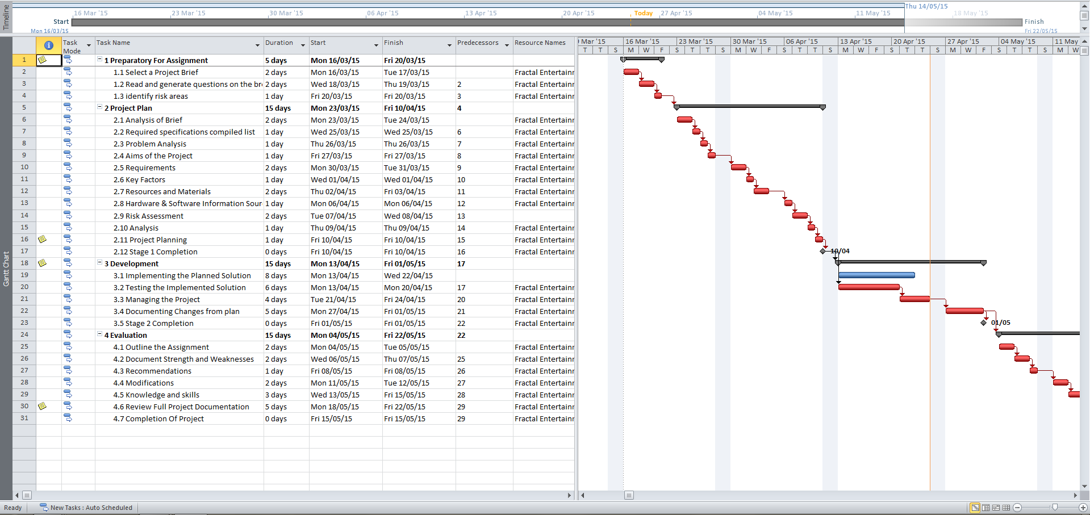

5.2

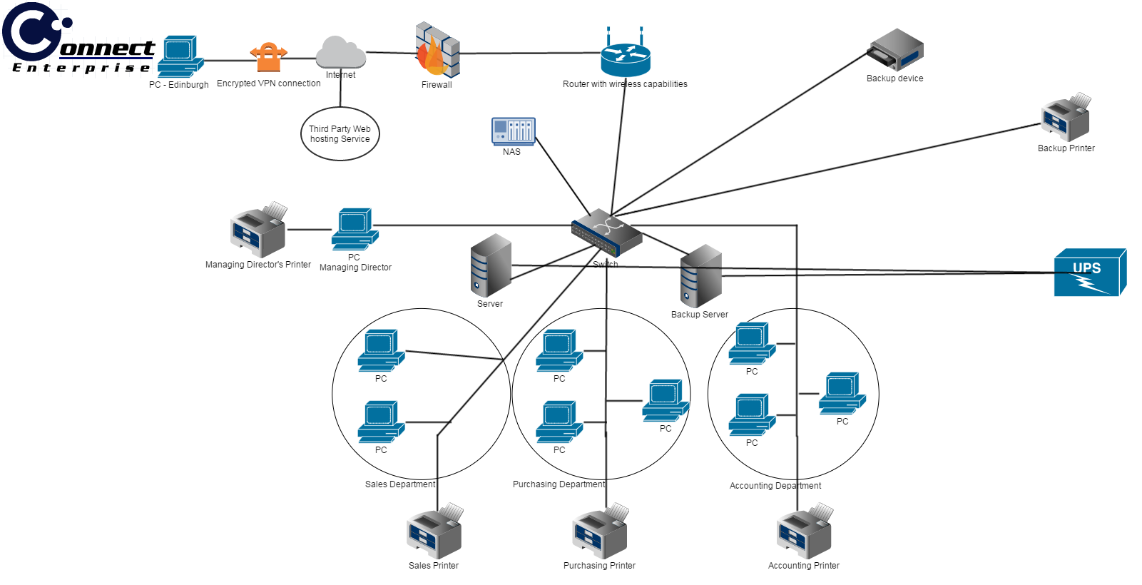

5.3

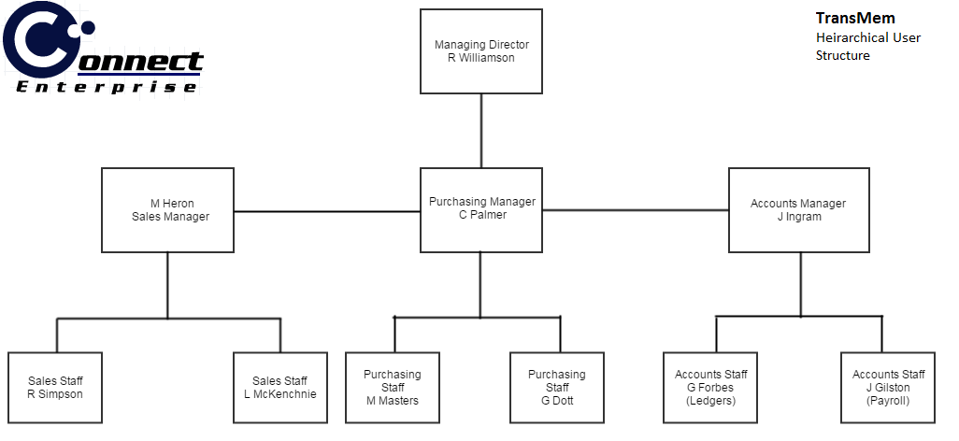

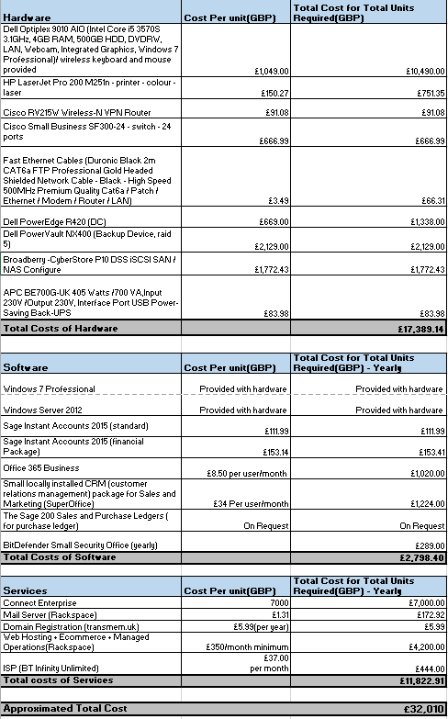

5.4

**INVOICE**

5.5

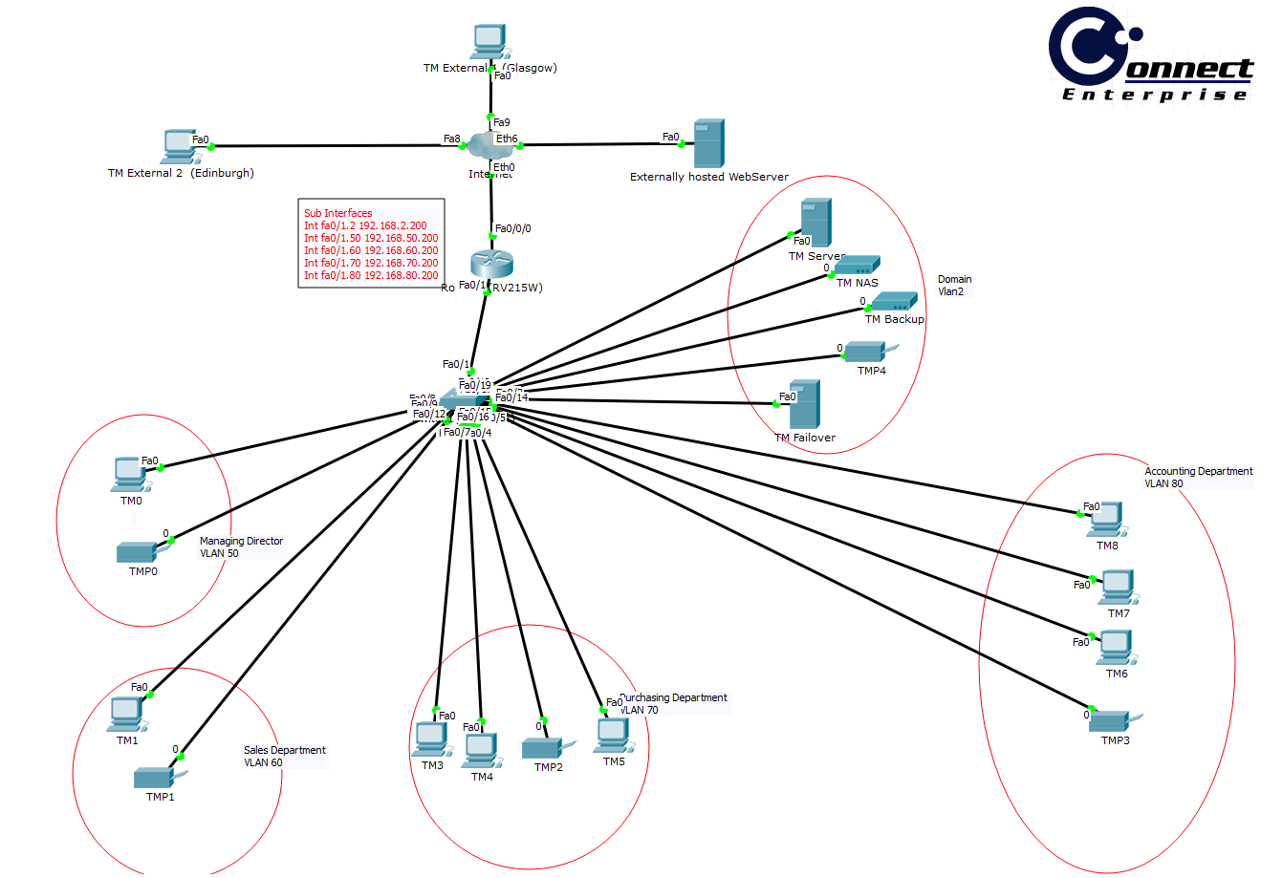

5.6

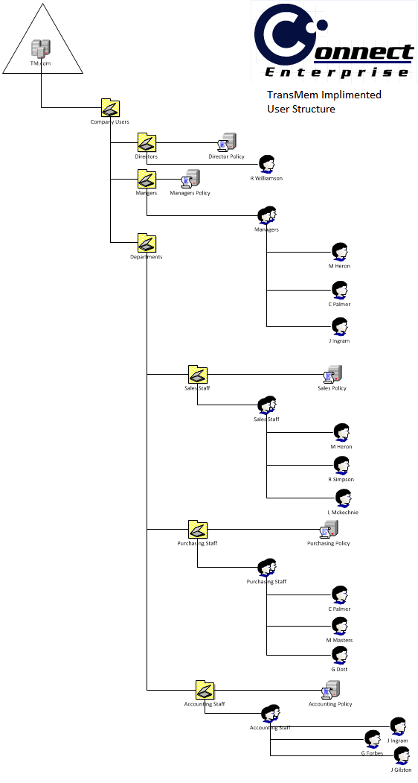

5.7

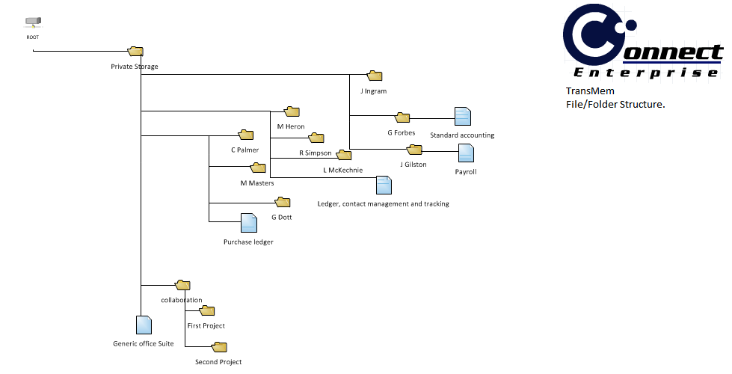

5.8

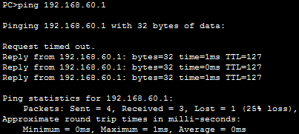

5.9

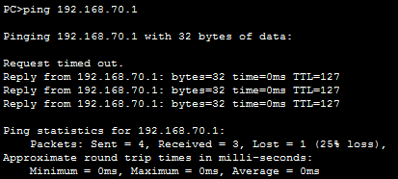

5.10

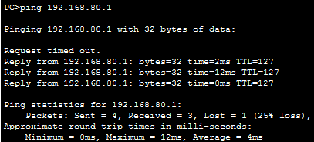

5.11

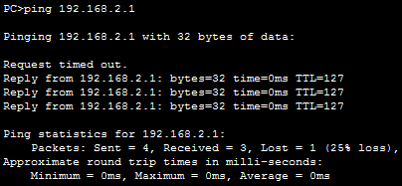

5.12

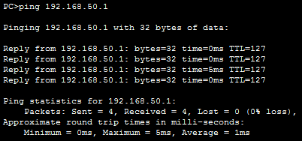

5.13

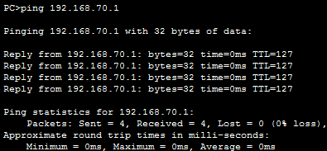

5.14

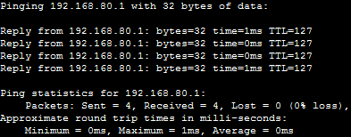

5.15

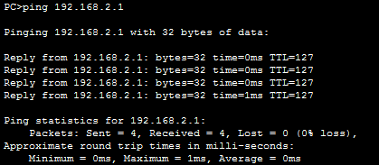

5.16

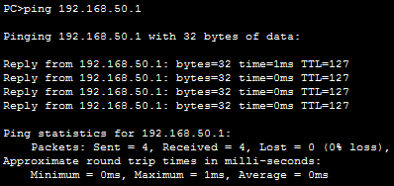

5.17

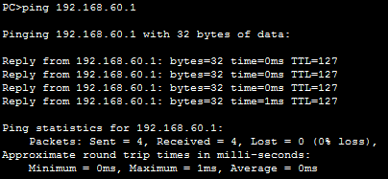

5.18

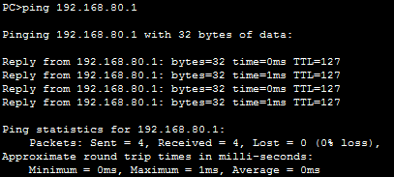

5.19

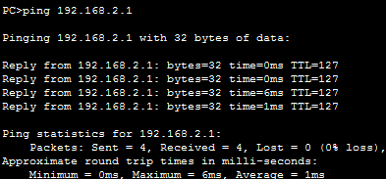

5.20

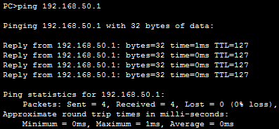

5.21

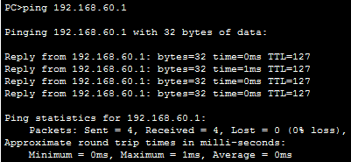

5.22

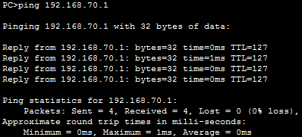

5.23

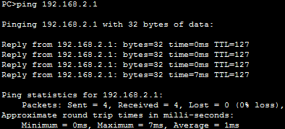

5.24

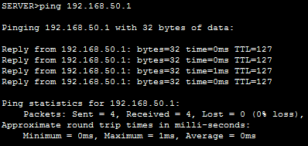

5.25

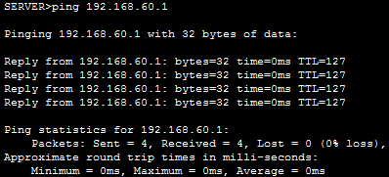

5.26

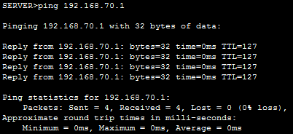

5.27

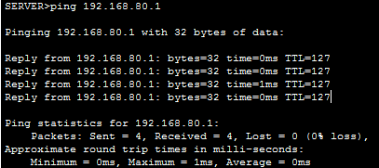

5.28

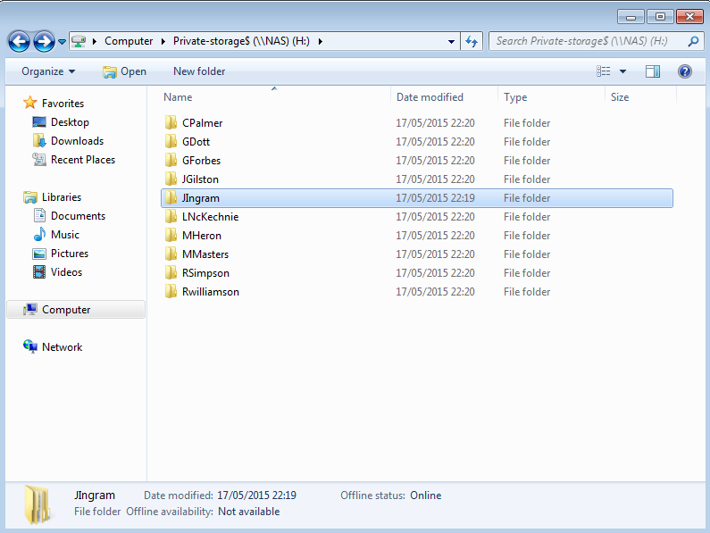

5.29

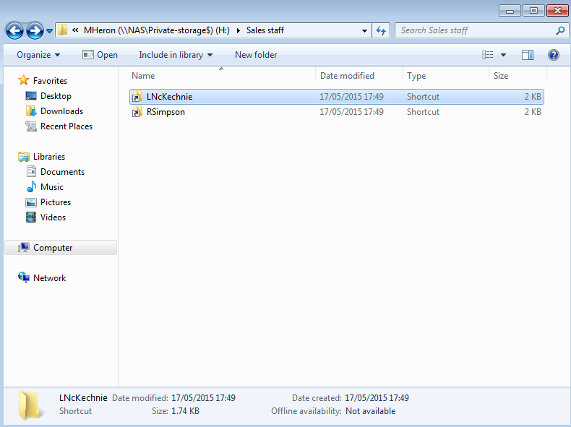

5.30

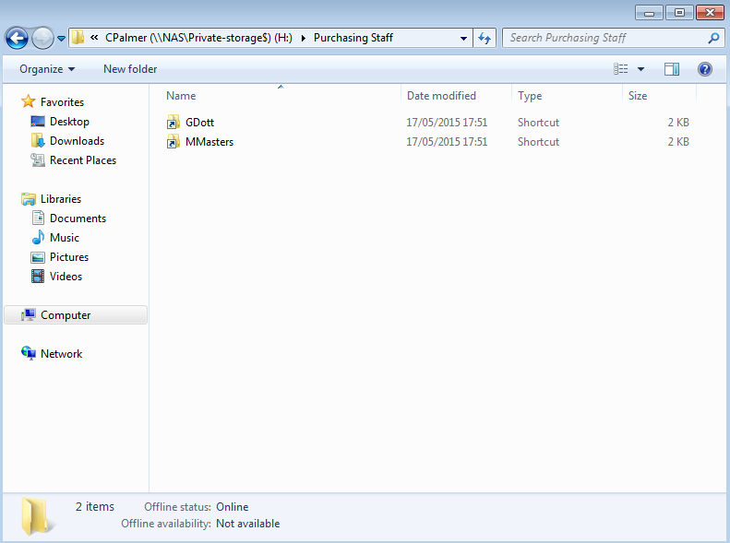

5.31

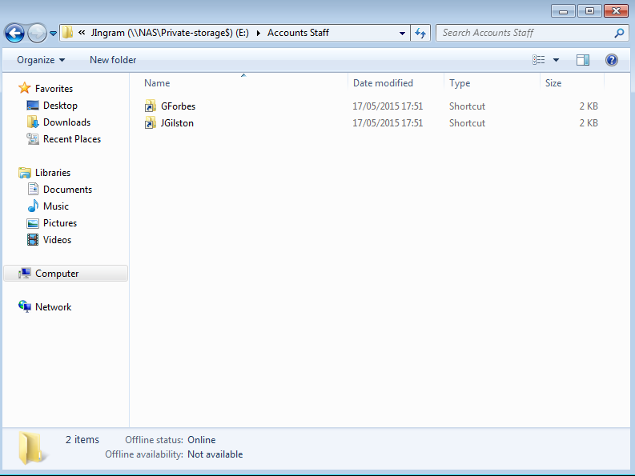

5.32

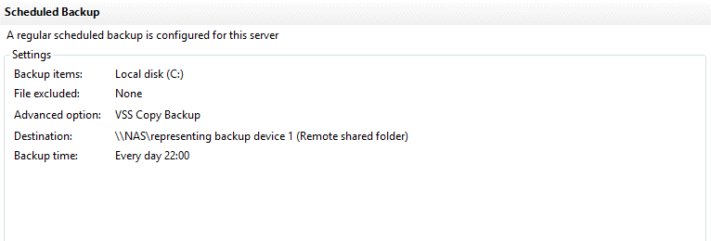

**6.0 Appendix B**

What is ad-hoc network? - Definition from WhatIs.com. 2015. What is ad-hoc network? - Definition from WhatIs.com. [ONLINE] Available at: [://searchmobilecomputing.techtarget.com/definition/ad-hoc-network](http:///h). [Accessed 16 March 2015].

What Internet Speed do I Need for my Business? 2015. What Internet Speed do I Need for my Business? [ONLINE] Available at: <http://www.ciinc.com/business-internet-speed/>. [Accessed 23 March 2015].